Design Patterns

Sias Rental Platform is a design mode based on cloud server and web page as service interface. All its services (including uploading, purchasing and editing rental goods, updating and maintaining websites and databases, etc.) are real-time. The reason why we choose this mode is that it can minimize the user's operational difficulty, avoid frequent client upgrades and operate across platforms.

We are well aware that web-based leasing platforms require higher user interface and data stability than clients, especially when it comes to money transactions. However, in view of the fact that the website is still in its infancy, its user size is small, and it mainly faces the users of Sias campus, we choose the design mode of rental platform based on three servers:

One deployment application, one deployment database and one deployment NFS file system.

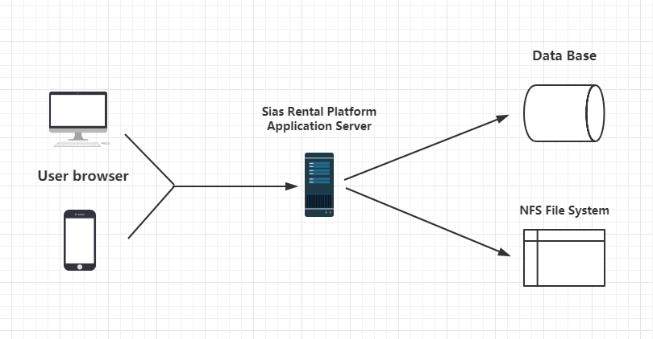

If the platform develops rapidly, the increase of the number of users will also improve the stability and response speed of the platform. At this time, the primary service architecture has been difficult to meet the demand. It is expected that we will change to cluster server mode to meet the highly available design.

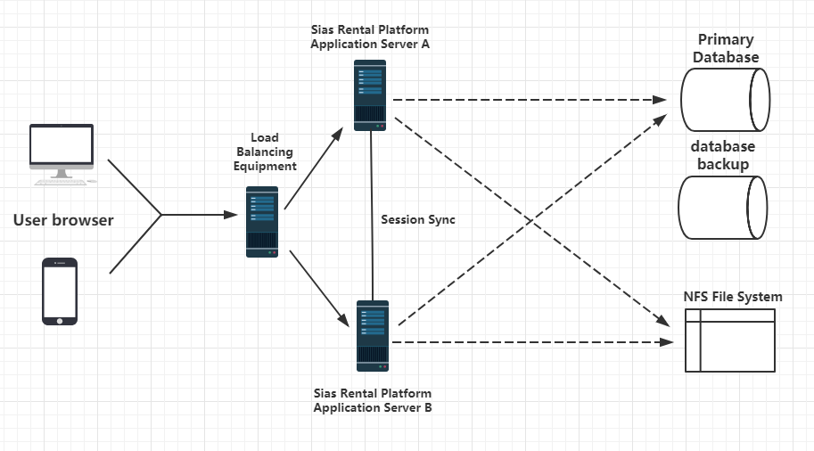

Use clusters to redundate application servers for high availability (load balancing devices can be deployed with applications);

Use database active and standby mode to achieve data backup and high availability;